**HOW TO REPORT and TRACK bugs/tasks with TRAC tickets system for EHOST development and debug**

Jianwei Chris Leng  
April 12, 2011

Login

### Log into the ProjectLocker System

Make sure you have logged in the TRAC system on Project Locker for project of eHOST before you try to report or track your bug/task. URL of <https://portal.projectlocker.com/> can be used to reach the portal of “ProjectLocker”.

### Enter webpage of “Trac” by clicking link of “Trac”

Just as following screenshot:

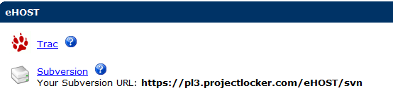

Report a new bug/ Assign a new task by creating a new Ticket

### Create New Ticket for new bug or new task

In the TRAC system, they consider all problems, bugs, tasks or refining works as tickets. So, if you want to report a bug, or assign a new task to someone, what you need to do is just to create a new ticket in the TRAC system.

After you logged in the system, clicking the “new ticket” link on the top of webpage of “Trac” can lead you to the webpage of “create new ticket”. At that webpage, you are allow to enter contents to create a new ticket, as follows:

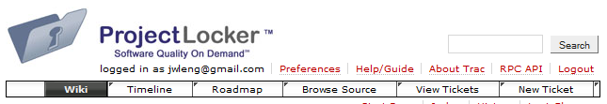

### Details of New Ticket

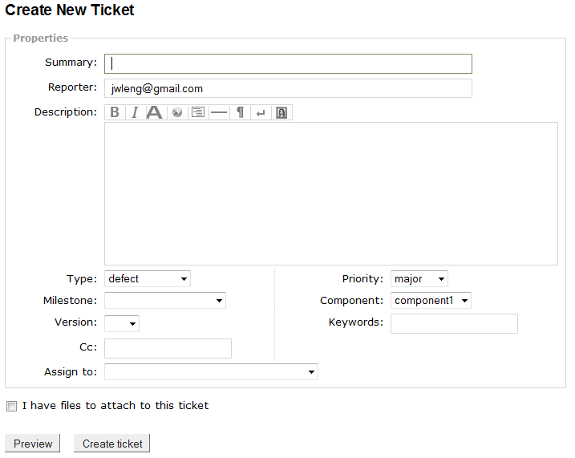  
There are three kinds of tickets. You need to pick up one as you need.

*“defect” - bugs or problems  
“enhancement” - refining works  
“task” - can be considered as new task or new features*

*Summary:* the topic of your ticket. Just put a short description to your bug, task or refining work here;

*Reporter:* reporter’s email address;

*Assign to:* the person who will get this ticket and handle it. She/He will got a email while you clicked the “Create ticket”.  
*CC:* persons who also get CCed for this problem/task;

*Description:* Details of this bug/task/refining work;

And if you want to attach any files, please selected the checkbox of “I have files to attach to this ticket” and then selected the files at the new step.

View/Track your reported bugs or assigned problems

Users can enter the menu by clicking the link of “view tickets” on the top of webpage of TRAC system.

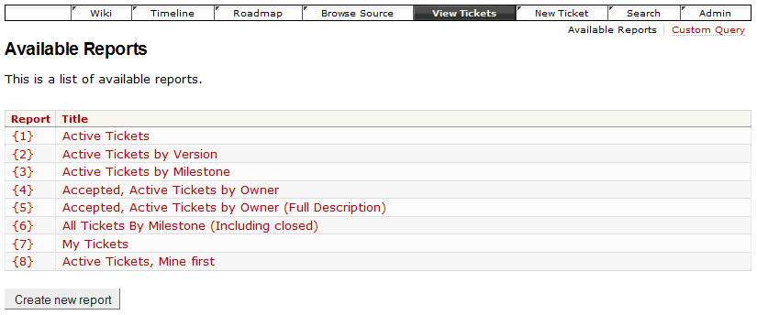

### Click active tickets to view all your current tickets (tasks/bugs …)

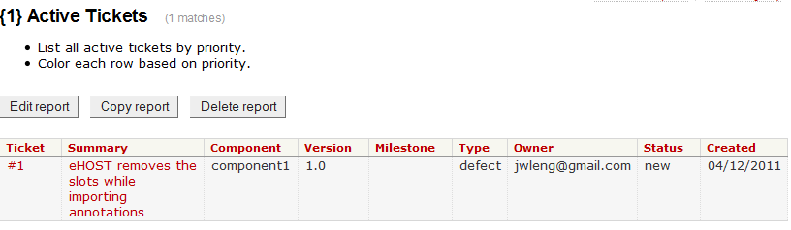  
On the tickets viewer page, you can click the ticket to see more details.

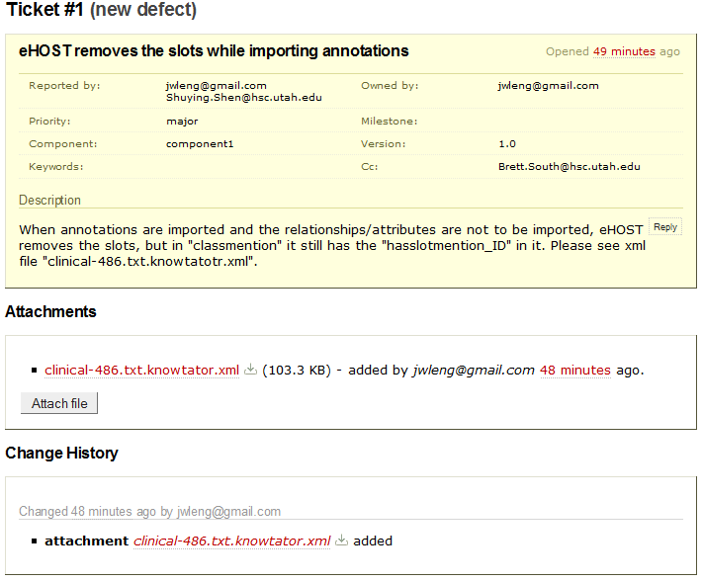

Response to tickets

While you are checking the details of tickets on above webpage, you can modify attributes to that ticket to record your response to the task/bug/ that you just got assigned. So the team leader or your colleagues can know your opinions.

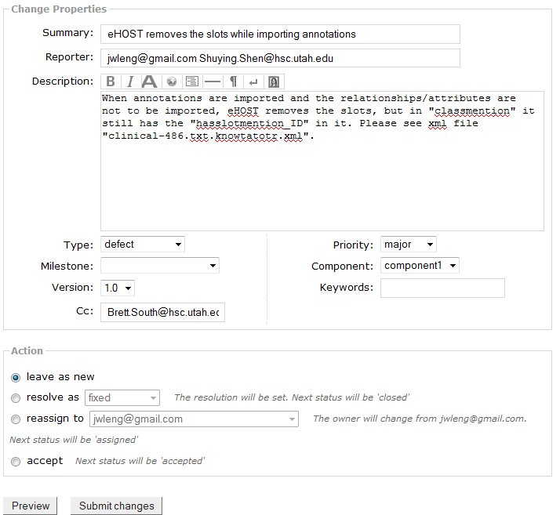

Usually, the first step we need to do after got a new ticket in the TRAC system is to check the “accept” button for the item of “action”. Of course, you also can select other response, such as “reassign to” to reassign this task to others.

Choose “resolve as ‘fixed’” after you fixed a bug or problem.